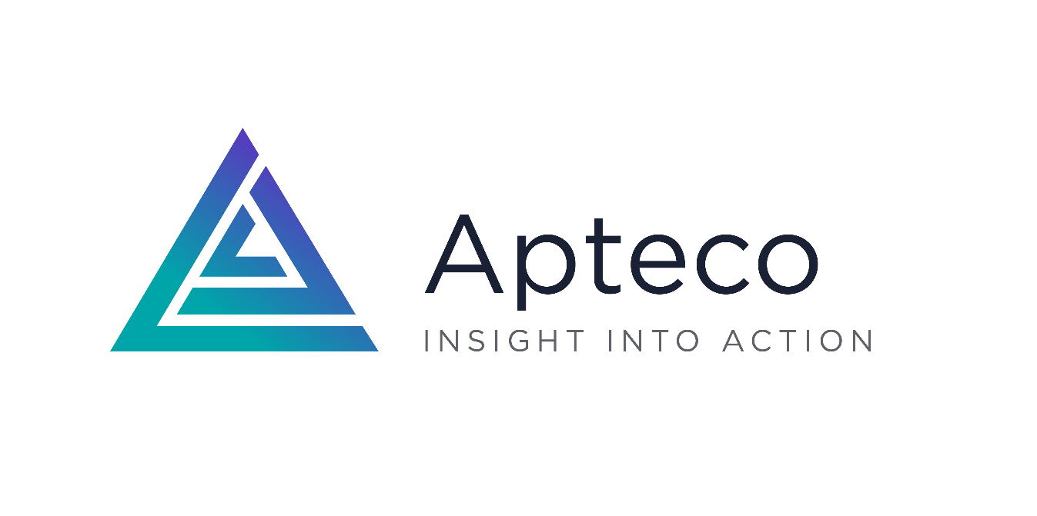

Best use of Apteco award 2025

Celebrating marketing excellence

## Entry form



Apteco, Tink-a-Tank House, 21 Jury Street, Warwick, CV34 4EH, UK

**T** +44 (0) 1926 407565

**E** [marketing@apteco.com](mailto:marketing@apteco.com)

**W** [www.apteco.com](https://www.apteco.com/)

Entry guidelines

**This year, the spotlight shines even brighter as we bring the annual Apteco award to the legendary BFI in London – a venue that celebrates storytelling in all its forms. And now, it’s your turn to take centre stage.**

The Best use of Apteco award 2025 honours the most inspiring and impactful use of Apteco software to elevate marketing performance and the use of insight to transform the customer experience. We’re looking for data-driven stars who’ve delivered measurable success, tackled big challenges with creativity, and helped their organisations thrive.

Whether your campaign was a box office smash or a hidden gem, we want to hear how you’ve used data, analytics and automation to make a real difference. This is your chance to be recognised by your peers and celebrated for the incredible work you do behind the scenes.

So, roll out the red carpet for your achievements and submit your entry today. The winner will be revealed live at Apteco Live 2025.

How will entries be judged?

Our panel of Apteco judges will score each entry out of 50, spotlighting those that demonstrate exceptional and imaginative use of Apteco software. The top entries will then take to the big screen – with each finalist presenting a short video at Apteco Live 2025.

But the story doesn’t end there. Delegates at the event will cast their votes, awarding up to 50 additional points based on peer appraisal. The entry with the highest combined score out of 100 will take home the award and the applause.

**What are the judges looking for?**

To earn top billing, your entry should showcase:

* **Effective and skilful use** of Apteco software
* **Creative application** to meet business and marketing goals
* **Strategic thinking** - how Apteco helped shape or evolve your marketing approach
* **Tangible improvements** to the customer experience
* **Commercial impact** – from ROI and campaign performance to streamlined processes

**Entry criteria**

* All entries must be based on projects / results that have been carried out or achieved over the past 12-18 months using licensed software from Apteco.
* All entrants must hold an up to date Apteco software licence that is valid on 13 November 2025.
* Only one entry can be made per Apteco system.
* Entries may be submitted directly from an end client, their Apteco partner / reseller, or as a joint entry from both the end client and their partner / reseller.
* The author(s) of the top selected entries **must prepare a 10-minute video presentation** which will feature as part of the Apteco Live 2025 conference agenda. Apteco will review the presentation slides with each finalist to help ensure they can present a compelling case to the delegates. The presentations will be pre-recorded and Apteco will set up online recording sessions with a professional recording studio on **Tuesday 21 and Wednesday 22 October**. Alternatively finalists can submit their own recorded presentations in MP4 format by 5pm on Monday 3 November at the latest.
* The author(s) of the top selected entries are also invited to attend the Apteco Live 2025 in-person conference on Thursday 13 November at the BFI in London and **take part in an informal networking session**. This session will be held over the lunch period where finalists can speak to interested delegates about their submission. A poseur table and branded desktop sign will be provided and finalists have the option to bring a small single branded pull-up exhibition graphic.
* One author from each of the top selected entries will be invited to **join a panel session on stage at Apteco Live 2025** to discuss their entry. More information will be provided and arrangements agreed nearer the time.

**Submission guidelines & word limit**

* Email [**marketing@apteco.com**](mailto:marketing@apteco.com) in advance to let us know that you are planning to submit an entry.
* **This entry form must be completed and emailed to** [**marketing@apteco.com**](mailto:marketing@apteco.com) **by 5pm on Friday 26 September 2025**. If you have any queries or if you haven't received an email confirming receipt of your submission within two working days, please email marketing@apteco.com or call +44 (0)1926 407565.
* Please provide a .png, .jpg or .gif file of your company logos with your entry form.
* Apteco will confirm the top selected entries (the finalists) on **Monday 6 October 2025**.
* Part 2 of the completed form must contain no more than 350 words.
* Part 3 of the completed form must contain no more than 2000 words.
* Support materials such as charts, graphs, visualisations and reports can be inserted into the entry form or attached to your submission email. Any text explaining or referencing the support materials must appear in part 3 of the entry form and will count towards the 2000-word limit.
* We recommend that you provide headline results that clearly show your success as a result of using Apteco software.

**Confidentiality**

* Selected entries will be published on the Apteco.com website as a case study and used in marketing materials. They may also be published on other Apteco domains, including Apteco.de, Apteco.com.au and Apteco.nl.
* Any sensitive information must be clearly identified on the entry form by highlighting it in red text. This information will not be published on any Apteco website or in any marketing material.
* All sensitive material will remain confidential to the judges.
* If your entry is selected as one of the finalists, then Part 2 of your entry form will be provided to delegates at the Apteco Live 2025 conference. Do not include any confidential information in this section.

**Authorisation**

* By submitting an entry on behalf of your company or a client you are confirming that you have received authorisation to do so.

**Award presentation & prizes**

* The winning entry will be announced at the end of the day at the Apteco Live conference on **Thursday 13 November 2025**.
* The author of the winning entry will win a pair of RAY-BAN Smart Sunglasses worth around £300.
* If two people are responsible for the entry (client or partner staff) then this must be stated on the entry form and both will receive a pair of RAY-BAN Smart Sunglasses.
* The authors of the runner up entries will each receive a bottle of Champagne.
* The decision made by the judges is final.

We look forward to receiving your completed entry form, so enter now and let your data brilliance shine.

**The Apteco Team** (Warwick, UK)

Entry form

Part 1: General information

**Author details**

Please complete your details in the box below.

*NB: If successful the authors detailed here will each receive a prize as detailed above.*

|  |  |  |
| --- | --- | --- |
|  | ***Author 1*** | ***Author 2*** |
| **Name:** |  |  |
| **Job Title:** |  |  |
| **Company:** |  |  |
| **Company Address:** |  |  |
| **Telephone Number:** |  |  |
| **Email address:** |  |  |
| **Website address:** |  |  |
| **X / Twitter handle:** | @ | @ |
| **LinkedIn company page:** |  |  |

**Presentation & networking session**

Please confirm that you are available to prepare a 10-minute pre-recorded presentation in preparation for the 2025 Apteco Live conference on either Tuesday 21 or Wednesday 22 October. Award entry presentations will form part of the agenda of the day, giving you the opportunity to showcase your work before delegates are invited to vote for their favourite entry.

Yes/No *(delete as appropriate)*

**Authorisation**

Please confirm that you have authorisation to submit this entry on behalf of your company and / or your client (if applicable) and that you / they are aware that selected entries will be published on the Apteco website and used in marketing materials.

Yes/No *(delete as appropriate)*

**Company overview**

Please provide a 250-word max overview of the company whose Apteco system is being referred to in your entry.

Type here...

Part 2: Overview of your ‘Best use of Apteco’

**Overview**

Provide a short 350-word summary of your “Best use…” case.

*NB: This summary will be provided to delegates at the Apteco Live conference who will be voting for their favourite entry. Please* ***don’t*** *include any confidential information.*

Type here...

Part 3: Details of your ‘Best use of Apteco’

**Details**

Using a maximum of 2000 words give details about your “Best use…” case. For example, you can include information on the initial project requirements / objectives, the solution offered, how Apteco software was used to meet objectives, screenshots of visualisations / reports, details of any campaigns, details of results and measurable improvements such as response rates, uplift, return on investment, customer experience, increase in revenue / profits, process improvements, cost savings etc.

*NB: Sensitive information must be highlighted in red. If it is more appropriate then support materials such as charts, graphs, reports and visualisations can also be attached to your submission email. Any text explaining or referencing the support materials must appear below and will form part of the 2000-word count limit.*

Type here...

**Partner quote**

Please provide a max. 50-word quote of your experience of using Apteco software, and its benefit to your client’s company or project

Type here...

**End user quote**

Please provide a max. 50-word quote of your experience of using Apteco software, and its benefit to your company or project

Type here...